COAL LAB MANUAL

**Submitted to:**

Dr. Tauqir

Teacher assistant : Sir Shahzad

**Submitted By:**

Komal Shehzadi

Registeration no : 2016-CS-178

**Section:**

Section B

**Department:**

Department of Computer Science

**Institute:**

University of Engineering and Technology Lahore (Main Campus)



**Date of Submission:** March 29, 2018

# LAB 1

## TASK: Take a character input from keyboard and display it on screen

The description inside the “// ‘ ‘ // “ are the comments to make the code more clear. These are not the part of program.

**// PROGRAM //**

**// Taking input from Key Board //**

Org 100

**// by moving 1 in AH interrupt will produce a character input prompt on screen //**

MOV AH, 1

INT 21H

**// Displaying it on screen //**

MOV DL, AL

MOV AH, 2

INT 21H

ret

## Commands :

**Org 100 :** Set offset of the segment originated at 100hex

**MOV:** moves the contents of source instruction in destination and the syntax is as follows:

Mov Destination, Source

**INT 21H:** Call to DOS interrupt Handler

**Ret:** return statement to end the program

## OUTPUT:

When the above program is run following output screen is displayed first ‘a’ is input character and 2nd ‘a’ is the output character.

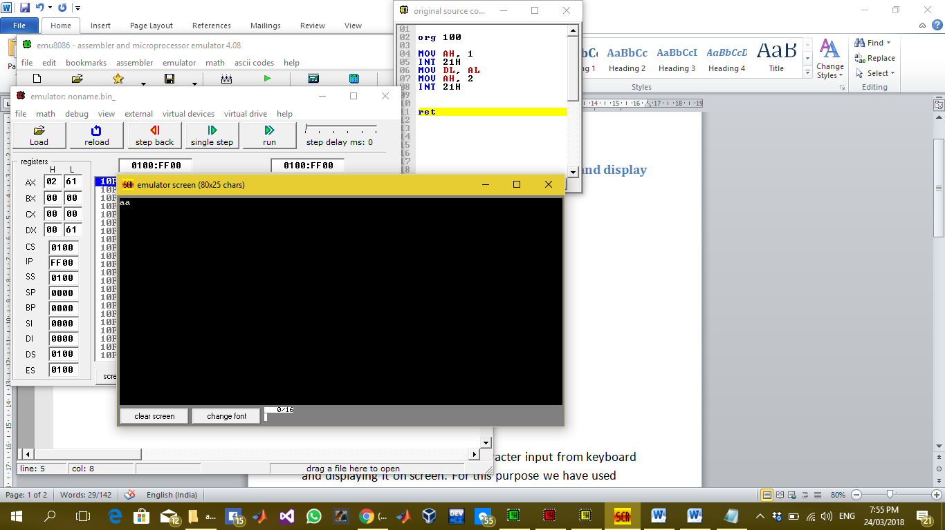

### Description:

In this lab task we are taking a character input from keyboard and displaying it on screen. For this purpose we have used interrupts after moving certain values in AH, AL and DL register

By moving 1 in AH register interrupt prompt screen to take character input from screen and that input will be saved in AL register automatically. So further we have moved 2 in AH register to display the character stored in DL register so move the AL contents in DL register and then produce interrupt so the input character would be displayed on screen.